Lab 4 tasks
Abdullah Ahmad | BCS – 3A | K25-0084

Q1.
#include <iostream>
using namespace std;

class book
{
string name;
string author;
string id;

public:
book()
{
name = "unknown";
author = "unknown";
id = "000";
}

// book(); // Default constructor

void setName(string str)
{
name = str;
}

void setAuthor(string au)
{
author = au;
}

void setID(string ID)
{
id = ID;
}

string getName()
{
return name;
}

string getAuthor()
{
return author;
}

string getID()
{
return id;
}

void Cancel()
{
cout << "\nThe reservation for " << name << " has been cancelled" << endl;
}

void printDetails()
{
cout << "\n"
<< name << endl;
cout << author << endl;
cout << id << endl;
}
};

int main()
{
book s1;
book s2;
book s3;

// s1.setName("DB");
// s2.setName("Bleach");
// s3.setName("Demon slayer");

// s1.setAuthor("akira toriyam");
// s2.setAuthor("tite kubo");
// s3.setAuthor("keine ahnung");

// s1.setID("001");
// s2.setID("002");
// s3.setID("003");

s1.printDetails();
s2.printDetails();
s3.printDetails();

// s1.Cancel();

return 0;
}

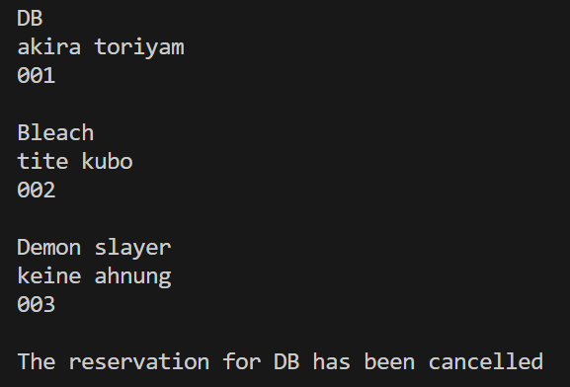

Q2.
#include <iostream>
using namespace std;

class Car
{
int id;
string modelName;
double rentPerDay;

public:
Car(int i, string m, double r) : id(i), modelName(m), rentPerDay(r) {}

void totalCost(int days)
{
cout << modelName << " rent is " << (rentPerDay * days) << endl;
}

void retire()
{
cout << modelName << " has successfully been retired from the fleet" << endl;
}
};

int main()
{
Car honda(001, "civic", 15);
honda.totalCost(5);
honda.retire();

return 0;
}

Q3.
#include <iostream>
#include <string>
using namespace std;

class patient
{
int id;
string name;
int *res;
int n;

public:
patient(int i, string nm, int s, int arr[])
{
id = i;
name = nm;
n = s;

res = new int[n];

for (int i = 0; i < n; i++)
{
res[i] = arr[i];
}
}

void set_res(int i, int v)
{
res[i] = v;
}

void show()
{
cout << "id: " << id << endl;
cout << "name: " << name << endl;
cout << "results: ";

for (int i = 0; i < n; i++)
{
cout << res[i] << " ";
}

cout << endl;
}
};

int main()
{
int arr[] = {1, 2, 3};

patient p1(001, "abde", 3, arr);

patient p2 = p1;

cout << "before update:" << endl;
p1.show();
p2.show();

p1.set_res(1, 50);

cout << "\nafter updating original:" << endl;
p1.show();
p2.show();

return 0;
}

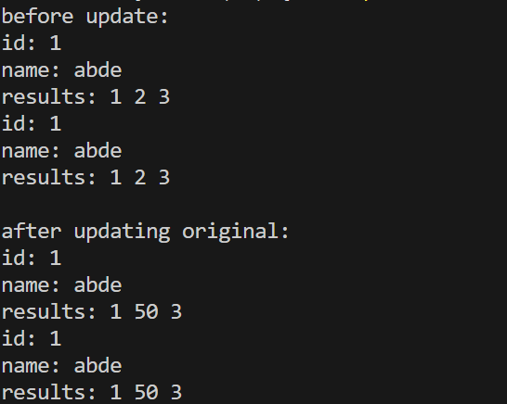

Q4.
#include <iostream>
#include <string>
using namespace std;

class booking
{
int room;
string type;
double* bill;

public:
booking(int r, string t, double b)
{
room = r;
type = t;

bill = new double;
*bill = b;
}

booking(const booking& b)
{
room = b.room;
type = b.type;

bill = new double;
*bill = *b.bill;
}

void set_bill(double b)
{
*bill = b;
}

void show()
{
cout << "room: " << room << endl;
cout << "type: " << type << endl;
cout << "bill: " << *bill << endl;
}

~booking()
{
delete bill;
}
};

int main()
{
booking b1(205, "deluxe", 15000);

booking b2 = b1;

cout << "before update:" << endl;
b1.show();
b2.show();

b1.set_bill(18000);

cout << "\nafter updating active booking:" << endl;
b1.show();
b2.show();

b2.set_bill(12000);

cout << "\nafter updating archived booking:" << endl;
b1.show();
b2.show();

return 0;
}

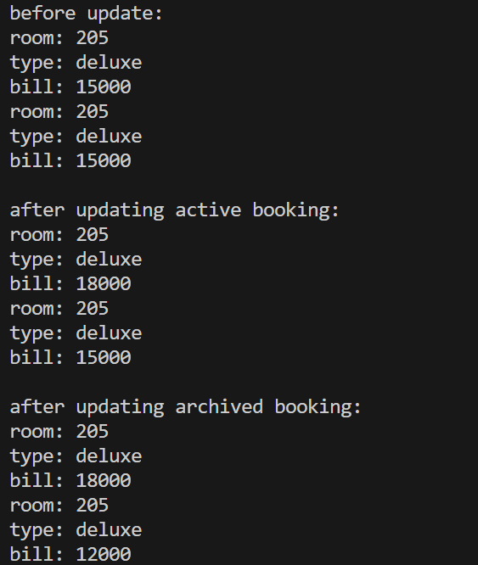

Q5.
#include <iostream>
#include <string>
using namespace std;

class doc
{
int id;
string title;
double* size;

public:

doc(int i, string t, double s)
{
id = i;
title = t;

size = new double;
*size = s;
}

doc()
{
id = 0;
title = "unknown";

size = new double;
*size = 0;
}

doc(const doc& d)
{
id = d.id;
title = d.title;

size = new double;
*size = *d.size;
}

void set_size(double s)
{
*size = s;
}

void show()
{
cout << "id: " << id << endl;
cout << "title: " << title << endl;
cout << "size: " << *size << endl;
}

~doc()
{
delete size;
cout << "document cleaned up" << endl;
}
};

int main()
{
doc d1(101, "report", 250);

doc d2;

doc d3 = d1;

cout << "original:" << endl;
d1.show();

cout << "\nplaceholder:" << endl;
d2.show();

cout << "\npreview:" << endl;
d3.show();

d3.set_size(500);

cout << "\nafter changing preview:" << endl;

cout << "original:" << endl;
d1.show();

cout << "\npreview:" << endl;
d3.show();

return 0;
}

